**Project Design Phase-II**

**Data Flow Diagram & User Stories**

|  |  |
| --- | --- |
| Date | 24 June 2025 |
| Team ID | LTVIP2025TMID20428 |
| Project Name | FlightFinder |
| Mentor Name | Dr Shaik Salma Begum |
| Maximum Marks | 4 Marks |

**Data Flow Diagrams:**

A Data Flow Diagram (DFD) is a traditional visual representation of the information flows within a system. A neat and clear DFD can depict the right amount of the system requirement graphically. It shows how data enters and leaves the system, what changes the information, and where data is stored.

Example: DFD Level 0 (Industry Standard)

**Example: [(Simplified)](https://developer.ibm.com/patterns/visualize-unstructured-text/)**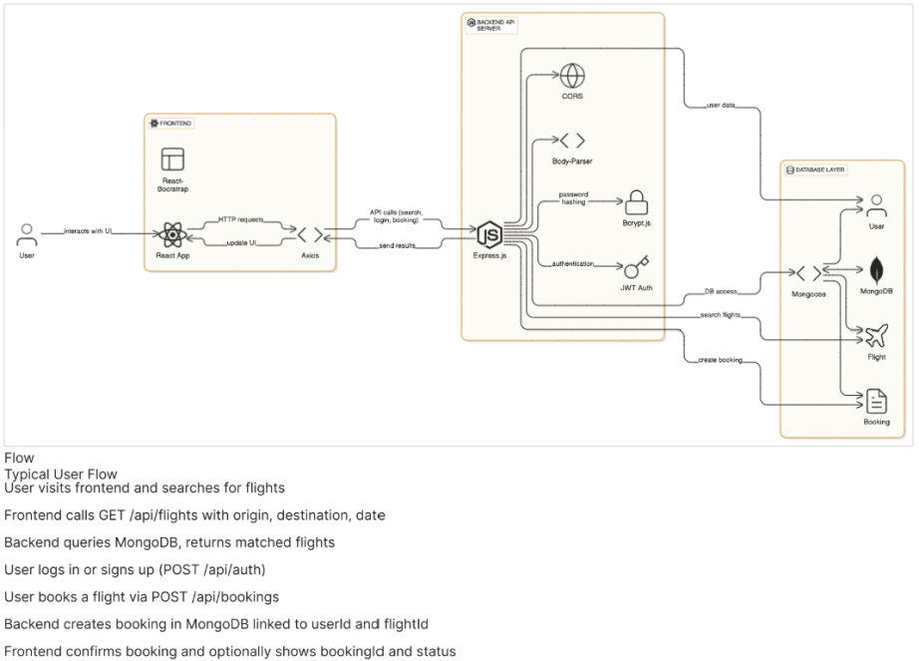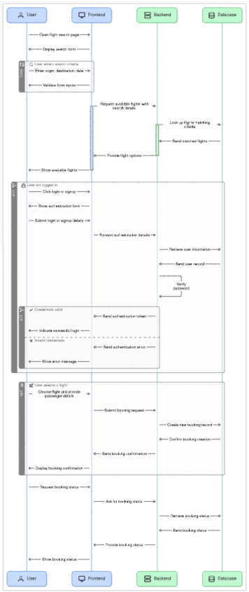

**User Stories**

Use the below template to list all the user stories for the product.

| **User Type** | **Functional Requirement (Epic)** | **User Story Number** | **User Story / Task** | **Acceptance criteria** | **Priority** | **Release** |
| --- | --- | --- | --- | --- | --- | --- |
| Customer (Mobile user) | Registration | USN-1 | As a user, I can register for the application by entering my email, password, and confirming my password. | I can access my account / dashboard | High | Sprint-1 |
|  | Login | USN-2 | As a user, I can log into the application using email and password | I can access my dashboard after logging in | High | Sprint-1 |
|  | Flight Search | USN-3 | As a user, I can search for flights based on source, destination, and date | Flights are listed based on search parameters | High | Sprint-2 |
|  | Filters & Sorting | USN-4 | As a user, I can filter and sort flights by price, duration, or airline | Filtered and sorted results are shown correctly | Medium | Sprint-2 |
|  | Booking | USN-5 | As a user, I can book a selected flight and receive booking confirmation | Booking is completed and confirmation email is received | High | Sprint-3 |
|  | Payment Integration | USN-6 | As a user, I can make payments using cards, UPI, or net banking | Payments are processed securely and receipts are generated | High | Sprint-3 |
|  | View Bookings | USN-7 | As a user, I can view my past and upcoming flight bookings | My bookings are listed under my account section | Medium | Sprint-4 |
| Customer (Web user) | Support Ticket | USN-8 | As a support agent, I can respond to user queries and complaints | Tickets can be responded to and resolved via admin dashboard | Medium | Sprint-4 |
| Administrator | Flight Management | USN-9 | As an admin, I can add, update, or remove flight listings | Changes reflect in public flight catalog | High | Sprint-4 |
|  | User Management | USN-10 | As an admin, I can manage user accounts and access levels | I can activate, deactivate, or update user roles | High | Sprint-4 |